Chapter – 3
Problem Statement and Proposed System Methodology
3.1 Problem Statement in EV Charging Infrastructure.
The rapid growth of electric vehicles (EVs) has led to an unprecedented demand for efficient and reliable charging infrastructure. As EV adoption increases, the existing charging networks face significant challenges in meeting the energy requirements of a growing number of vehicles. This situation is exacerbated by the limited availability of charging stations, often resulting in long waiting times and user frustration. Additionally, the reliance on traditional grid power presents sustainability concerns, as it does not fully leverage renewable energy sources that are critical for reducing carbon emissions.
Current charging infrastructure often lacks uniform standards, leading to compatibility issues between different EV models and charging stations. Furthermore, there is a limited understanding of how to optimize the mix of renewable energy sources—such as solar power and Energy Storage Systems (ESS)to enhance charging efficiency. The economic viability of integrating vehicle-to-grid technology remains under-researched, leaving a gap in knowledge regarding its potential benefits and challenges.
The consumer behavior and preferences regarding EV charging solutions are still not well understood, which hinders the development of user-centric charging experiences. As smart city initiatives gain momentum, there is an urgent need for innovative solutions that can integrate IoT technologies to enhance the efficiency of EV charging infrastructure.
- Increased Demand for Charging Infrastructure
- Power Compatibility Issues
- Intermittency of Renewable Energy
- Limited Research on Renewable Energy Integration
- Economic Viability of Vehicle-to-Grid Technology
- Consumer Behavior Insights
- Sustainability Concerns
- Need for Smart Integration
- Operational Cost Challenges
- Scalability Issues
- Data Management Deficiencies
- User Experience Gaps
This project aims to address these challenges by proposing an Internet of Things (IoT) architecture for battery charging management that integrates solar energy, ESS, and grid power at the Point of Common Coupling (PCC). By utilizing real-time data monitoring and predictive analytics, this system seeks to optimize power demand, enhance battery management, and improve overall efficiency in EV charging operations. The proposed architecture will provide a scalable solution that not only meets current demands but also adapts to future growth in the EV market.
3.2 Proposed System Methodology
The proposed system for addressing the challenges in electric vehicle (EV) charging infrastructure focuses on developing an Internet of Things (IoT) architecture that seamlessly integrates multiple energy sources—solar power, Energy Storage Systems (ESS), and grid power—into a cohesive battery charging management solution. This architecture is designed not only to optimize charging operations but also to enhance user experience and promote sustainability.
The integration of solar power as a primary energy source is pivotal in this architecture, as it harnesses renewable energy to reduce reliance on traditional fossil fuels. By utilizing solar panels, the system can generate clean electricity during peak sunlight hours, which can be directly used for charging or stored in ESS for later use. This approach minimizes operational costs and contributes to environmental sustainability by lowering carbon emissions associated with conventional energy sources.
Energy Storage Systems (ESS) play a critical role in this integrated framework by providing a reliable means of storing excess energy generated from solar panels. During periods of low solar generation or high demand, the ESS can supply power to the charging stations, ensuring continuous operation without interruption. This capability addresses one of the significant challenges of renewable energy—its intermittency—by providing a buffer that enhances the reliability and stability of the charging infrastructure.
Grid power serves as a backup source in this architecture, allowing for flexibility in managing energy loads. When solar generation is insufficient and stored energy in the ESS is depleted, the system can automatically switch to grid power to ensure that charging operations continue seamlessly. This strategic use of grid electricity not only guarantees reliability but also allows operators to take advantage of varying electricity prices throughout the day, further optimizing operational costs.

3.2.1 proposed IOT Architecture layers
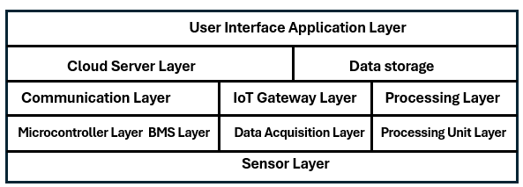
Fig 9 : Designed 5 Layered Architecture.
The proposed IoT architecture for battery charging management consists of five distinct layers, each playing a crucial role in optimizing the efficiency and effectiveness of electric vehicle (EV) charging operations.
1. User Interface Application Layer
This layer provides the front-end interface through which users interact with the charging system. It includes mobile applications and web platforms that allow users to monitor and manage their charging sessions in real-time.
A user can access a mobile app to find nearby charging stations, view their availability, and start or stop charging remotely. The app can also provide notifications about charging status, estimated time to completion, and energy consumption metrics.
2. Cloud Server and Data Storage
The cloud server acts as the central hub for data storage and analytics. It collects data from various sources, processes it, and stores it for future analysis. This layer enables predictive analytics, which helps in forecasting energy needs and optimizing charging schedules.
Data from multiple charging stations is aggregated in the cloud, where algorithms analyze usage patterns to predict peak demand times. This information can be used to adjust pricing strategies or manage energy distribution more effectively.

3. Communication Layer
This layer facilitates seamless connectivity between devices, sensors, and the cloud server using IoT gateways. It ensures that data is transmitted in real-time, allowing for effective monitoring and control of the entire system.
IoT gateways connect solar panels, ESS units, and charging stations to the cloud server. When a vehicle is plugged into a charger, the gateway transmits data about the vehicle's battery state and current energy availability to the cloud for processing.
4. Microcontroller Layer
The microcontroller layer includes Battery Management Systems (BMS) that process real-time data from sensors deployed throughout the charging infrastructure. This layer manages critical parameters such as voltage levels, temperature readings, and state-of-charge (SOC) of batteries.
A microcontroller monitors the temperature of battery packs during charging to prevent overheating. If temperatures exceed safe limits, it can automatically reduce the charging current or shut down the charger until conditions are safe.
5. Sensor Layer
The sensor layer consists of various sensors that collect critical data regarding environmental conditions and operational metrics. These sensors provide real-time information essential for managing charging operations effectively.
Sensors measure solar irradiance levels to determine how much solar power is available for charging. Additionally, current sensors monitor the flow of electricity during charging sessions to ensure that it remains within safe operational limits.
Integration of Layers
The integration of these layers creates a cohesive system capable of optimizing EV charging operations by leveraging real-time data monitoring and predictive analytics.
When solar energy generation is high, the system prioritizes solar power for charging.
If solar generation drops or demand increases beyond what solar can supply, the ESS activates to provide additional power. Grid power serves as a backup when both solar and ESS cannot meet demand.
The cloud server analyzes historical data to predict future energy needs, allowing for proactive adjustments in energy sourcing.
3.3 Proposed Flow
3.3.1 End to End power flow
This flowchart outlines the logic for managing the charging of batteries in a system that integrates multiple power sources: solar, energy storage systems (ESS), and the grid. The system aims to optimize battery charging by prioritizing renewable energy sources and utilizing the grid when necessary.
Start: The process begins with a check for available power sources.
Solar: If solar power is available, it is used to charge the battery.
ESS: If the ESS is available and not fully charged, it is charged.
Grid: If neither solar nor ESS is available, the grid is used for charging.

Charging Scenarios:
Solar ON, ESS Charge: If solar power is available and the ESS is not fully charged, solar power is used to charge the ESS, and the grid is turned off.
Solar ON, ESS > 80%: If solar power is available and the ESS is more than 80% charged, solar power is used to power the load directly, and the grid is turned on to provide backup power.
Solar OFF, ESS ON: If solar power is not available and the ESS has sufficient charge, the ESS is used to power the load.
Solar OFF, ESS < 20%: If solar power is not available and the ESS is less than 20% charged, the grid is used to power the load.
Output loads:
Battery Swapping Station: The system can support battery swapping stations by providing charged batteries.
DC Fast Charging Station: The system can enable DC fast charging of electric vehicles.

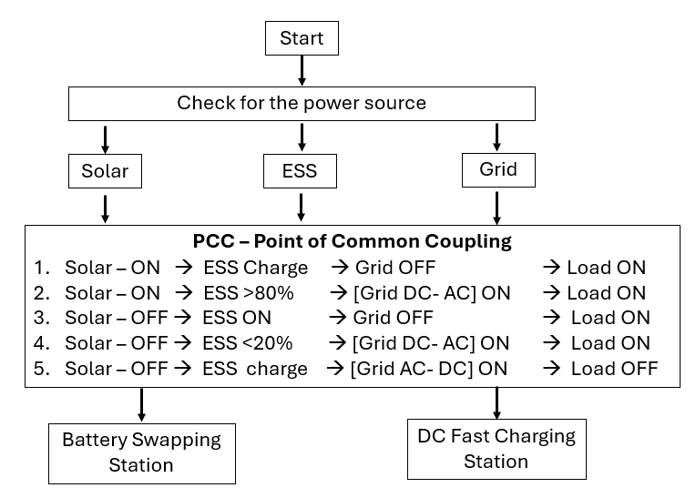
Fig 10 : PCC Control Flow
3.3.2 PCC Integration and Automation
This flowchart outlines the logic for integrating a Point of Common Coupling (PCC) with various power sources (solar, ESS, and grid) to optimize energy flow and manage battery charging.
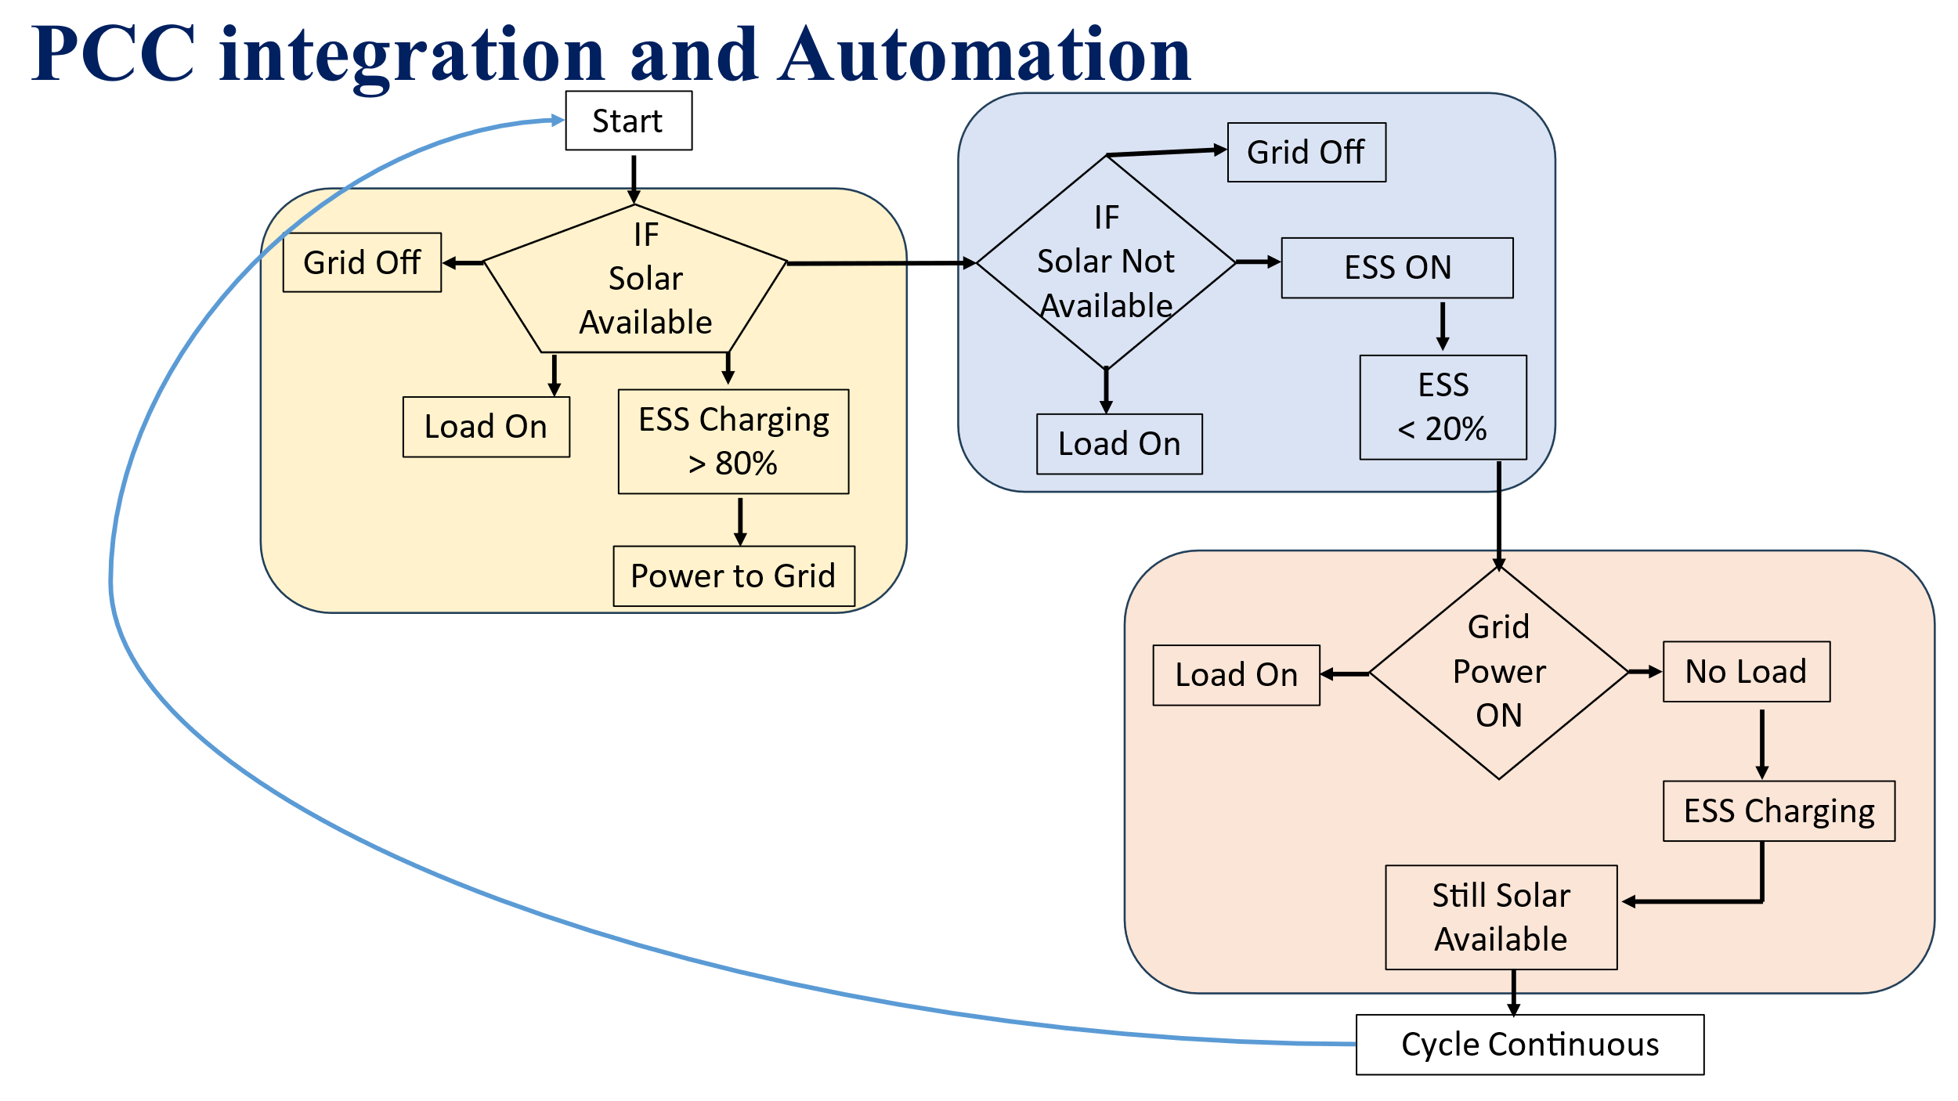
Fig 11 : PPC integration and Automation
Solar Available: If solar power is available, the ESS is charged to 80%. Once charged, excess solar power is fed back to the grid.
Solar Not Available: If solar power is not available, the ESS is used to power the load if it is above 20% charged. If the ESS is below 20%, grid power is used to power the load.
Grid Power ON: If grid power is available, it is used to power the load.
Grid Power OFF: If grid power is not available, the ESS is used to power the load if it is above 20% charged. If the ESS is below 20%, no load is powered.
Cycle Continuous: The process continues in a loop, checking for solar availability and adjusting power flow accordingly.
3.4.1 Algorithms
The demand for electric vehicles (EVs) continues to rise, the need for efficient and robust charging infrastructure has become increasingly critical. This documentation outlines the algorithms employed within the proposed Internet of Things (IoT) architecture for battery charging management, which integrates renewable energy sources such as solar power and Energy Storage Systems (ESS) with grid electricity. The algorithms are designed to optimize charging operations, enhance battery management, and improve overall efficiency.
State of Charge (SOC) Calculation Algorithm:
The SOC algorithm calculates the current state of charge of the battery based on voltage readings and predefined thresholds. It ensures that the SOC remains within acceptable limits to prevent overcharging or deep discharging, which can damage battery health.
Charging and Discharging Control Algorithm:
This algorithm manages when to charge or discharge the battery based on its SOC. If the SOC is above a certain threshold (e.g., 80%), the system will prioritize load operation while disabling charging. Conversely, if SOC falls below a specified level (e.g., 40%), the system will turn off loads and initiate charging.
Maximum Power Point Tracking (MPPT) Algorithm:
The MPPT algorithm optimizes the power output from solar panels by continuously adjusting the duty cycle based on real-time voltage and current measurements. This ensures that maximum energy is harvested from solar resources under varying environmental conditions.

Data Monitoring and Predictive Analytics Algorithm:
This algorithm collects real-time data from various sensors monitoring parameters such as voltage, current, temperature, and insulation resistance. It utilizes predictive analytics to forecast energy needs, allowing for proactive management of charging schedules and resource allocation.
Energy Source Management Algorithm:
This algorithm determines the optimal use of available energy sources—solar, ESS, or grid power—based on real-time conditions. It prioritizes solar energy first, utilizes stored energy from ESS when solar generation is insufficient, and resorts to grid power only when necessary.
The proposed project outlines an Internet of Things (IoT) architecture for battery charging management, addressing the growing demand for efficient electric vehicle (EV) charging infrastructure. This architecture integrates renewable energy sources, such as solar power and energy storage systems (ESS), with grid electricity to optimize charging operations. It consists of five distinct layers: User Interface Application Layer, Cloud Server and Data Storage, Communication Layer, Microcontroller Layer, and Sensor Layer. By leveraging real-time data monitoring and predictive analytics, the system aims to enhance battery management and improve overall efficiency in EV charging operations, achieving significant cost reductions—up to 90%—through optimized resource utilization. The methodology emphasizes a layered design that facilitates mobile and web access for users, while integrating multiple energy sources at the Point of Common Coupling (PCC). This approach not only addresses compatibility issues and the economic viability of vehicle-to-grid technology but also aligns with market demands driven by increasing EV sales and consumer preferences for renewable energy solutions. The future scope includes optimizing operational costs, improving customer engagement through real-time information, and enabling scalable infrastructure to adapt to changing market conditions. Ultimately, this IoT architecture promotes sustainable practices in the transportation ecosystem by maximizing the use of renewable energy sources.

Solar MPPT

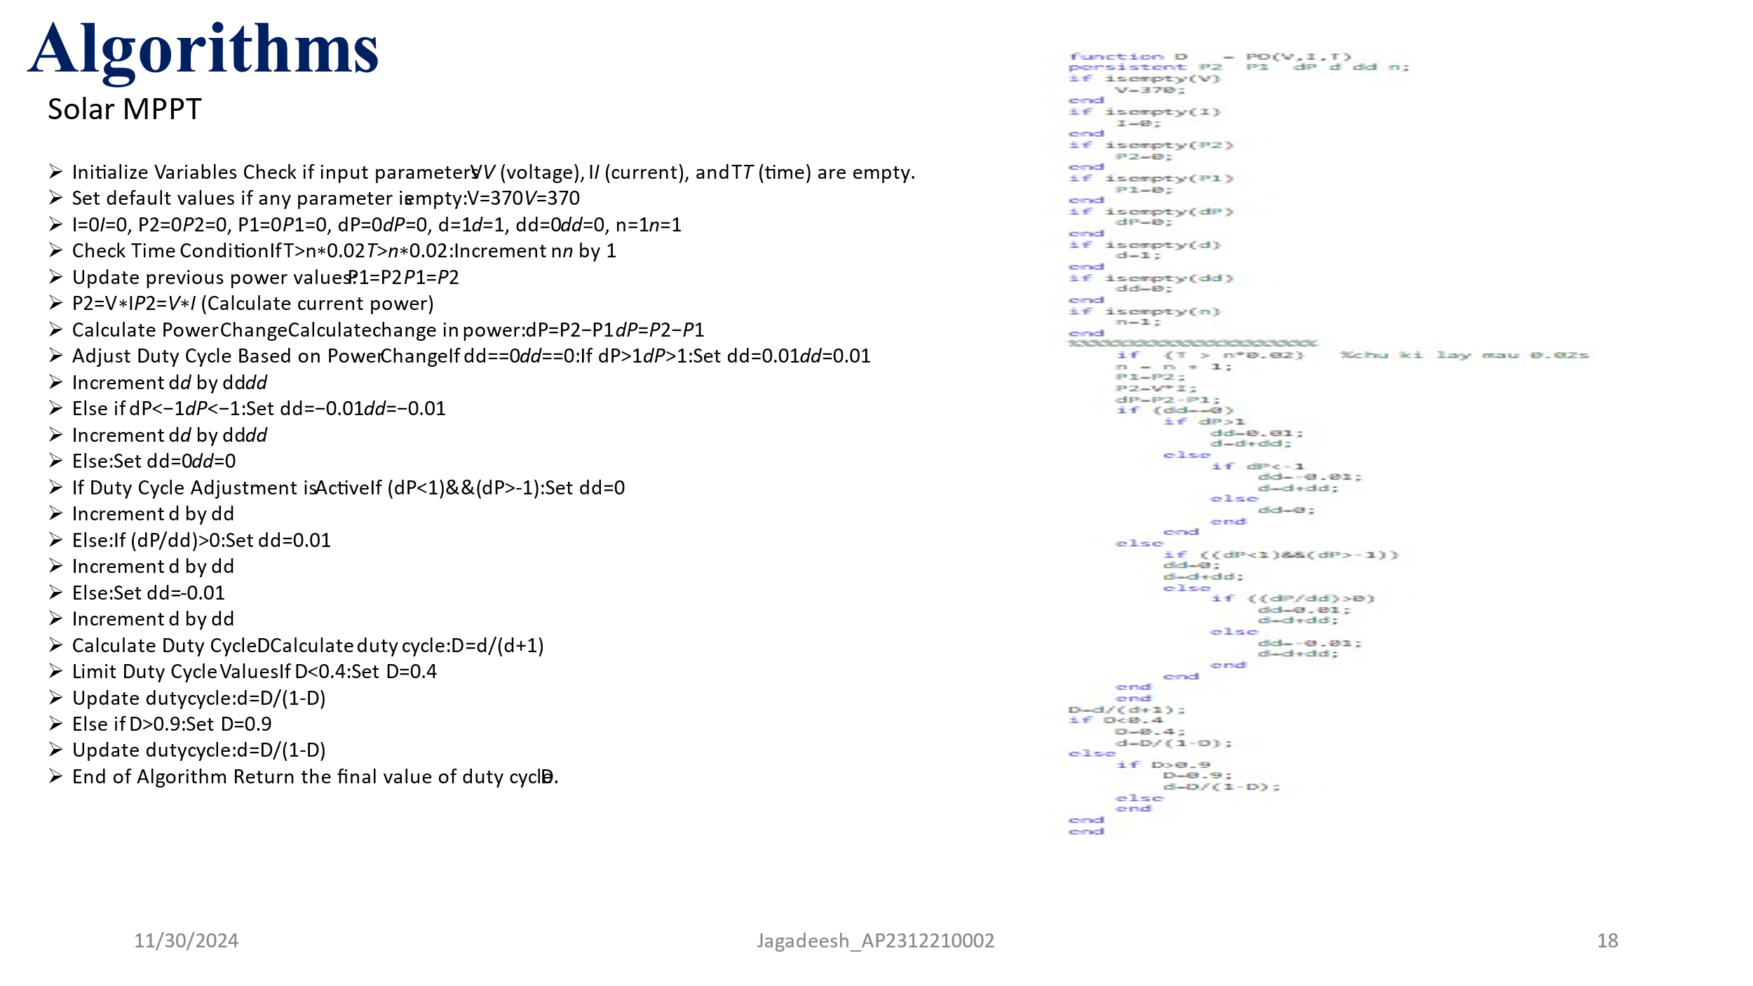
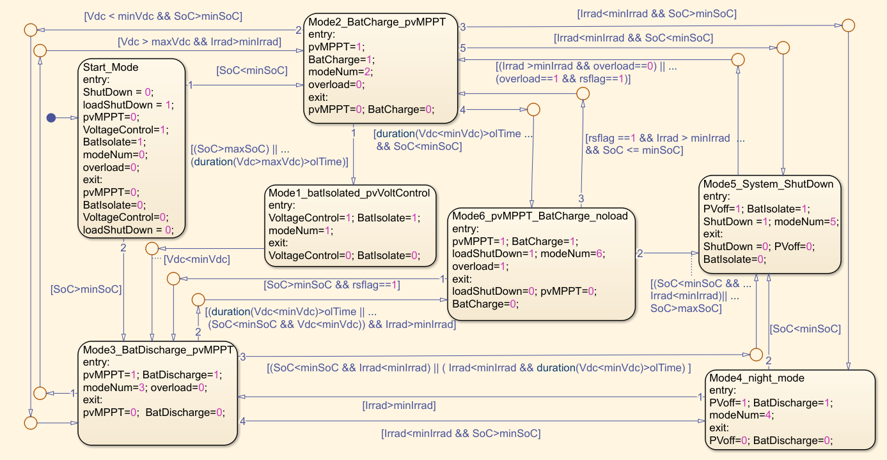

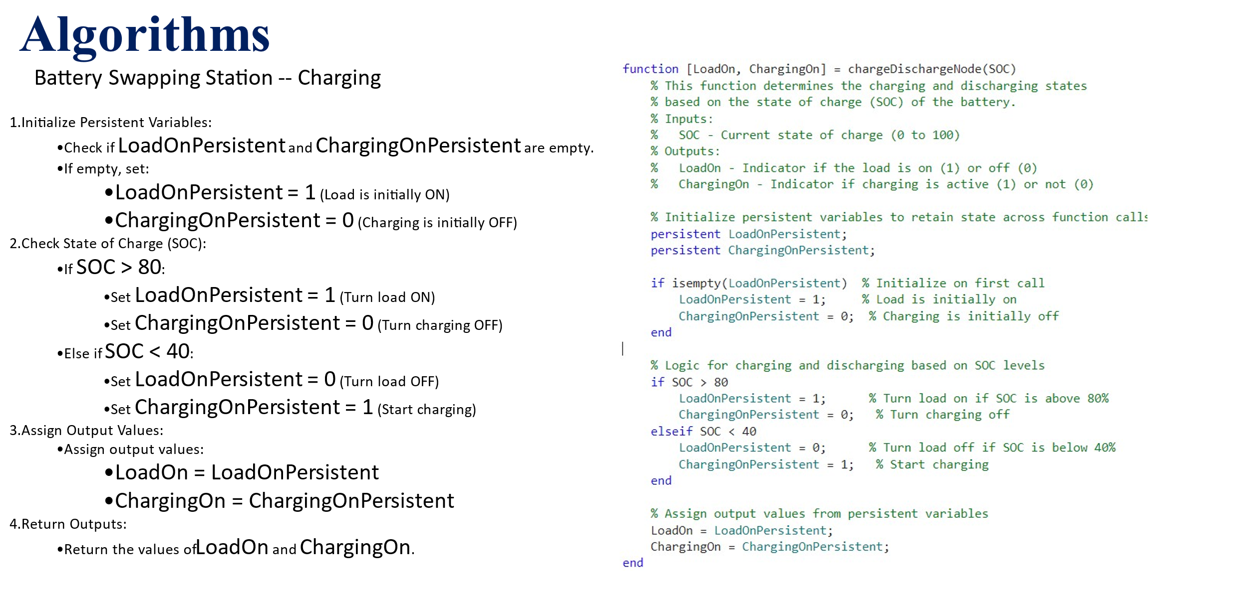

Vehicle Charging control calculation

